Installing/Updating the “Biometric” Middleware

The Biometric Middleware (BMW) is running as a windows service.

If BMW is installed **fresh** on a **new** machine it must be first installed as Service.

Please follow the steps below to install BMW fresh as service:

Use the whole content of the ZIP file (BiometricServer x.x.zip) for installation

* Copy the entire content of the ZIP file to any *arbitrary* folder e.g. C:\Biometric without the “*Release*” pathname
* Run cmd.exe as administrator !
* Navigate the console to C:\Biometric (or any other you have chosen)
* Run the command: BiometricServer.exe install
* Run the command: BiometricServer.exe start

The BMW application is now running as service and you can apply the usual service tasks like Start/Stop/....

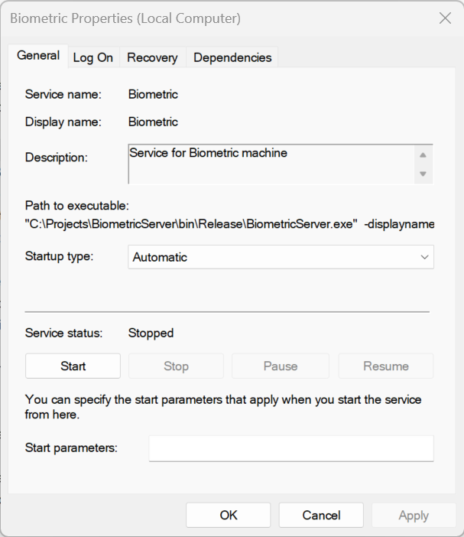

To **remove** (uninstall) the service simple call ***BiometricServer.exe uninstall*** from within the folder the exe resides.

Updating an existing Biometric installation:

* Stop the running service

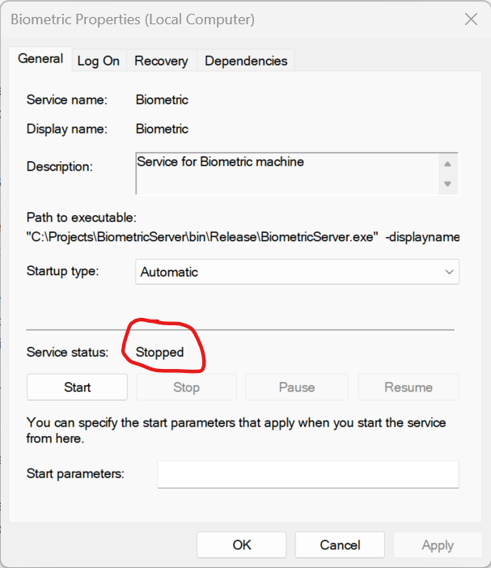

* Copy the file “***BiometricServer.exe.config***” to a save place (we need it later)
* Copy the entire content of the ZIP file (without the “Release” pathname) to the folder where the current installation exists, overwriting all former files.
* Copy the **saved** “*BiometricServer.exe.config*” back to its original location.
* Start again the service.

Hint: the “config” file contains important settings (e.g IP addresses, logger path, ....) and should therefore not be overwritten by the config file which comes with the new ZIP archive.